MongoDB Lab-1

Environment setup and DB and collection creation.

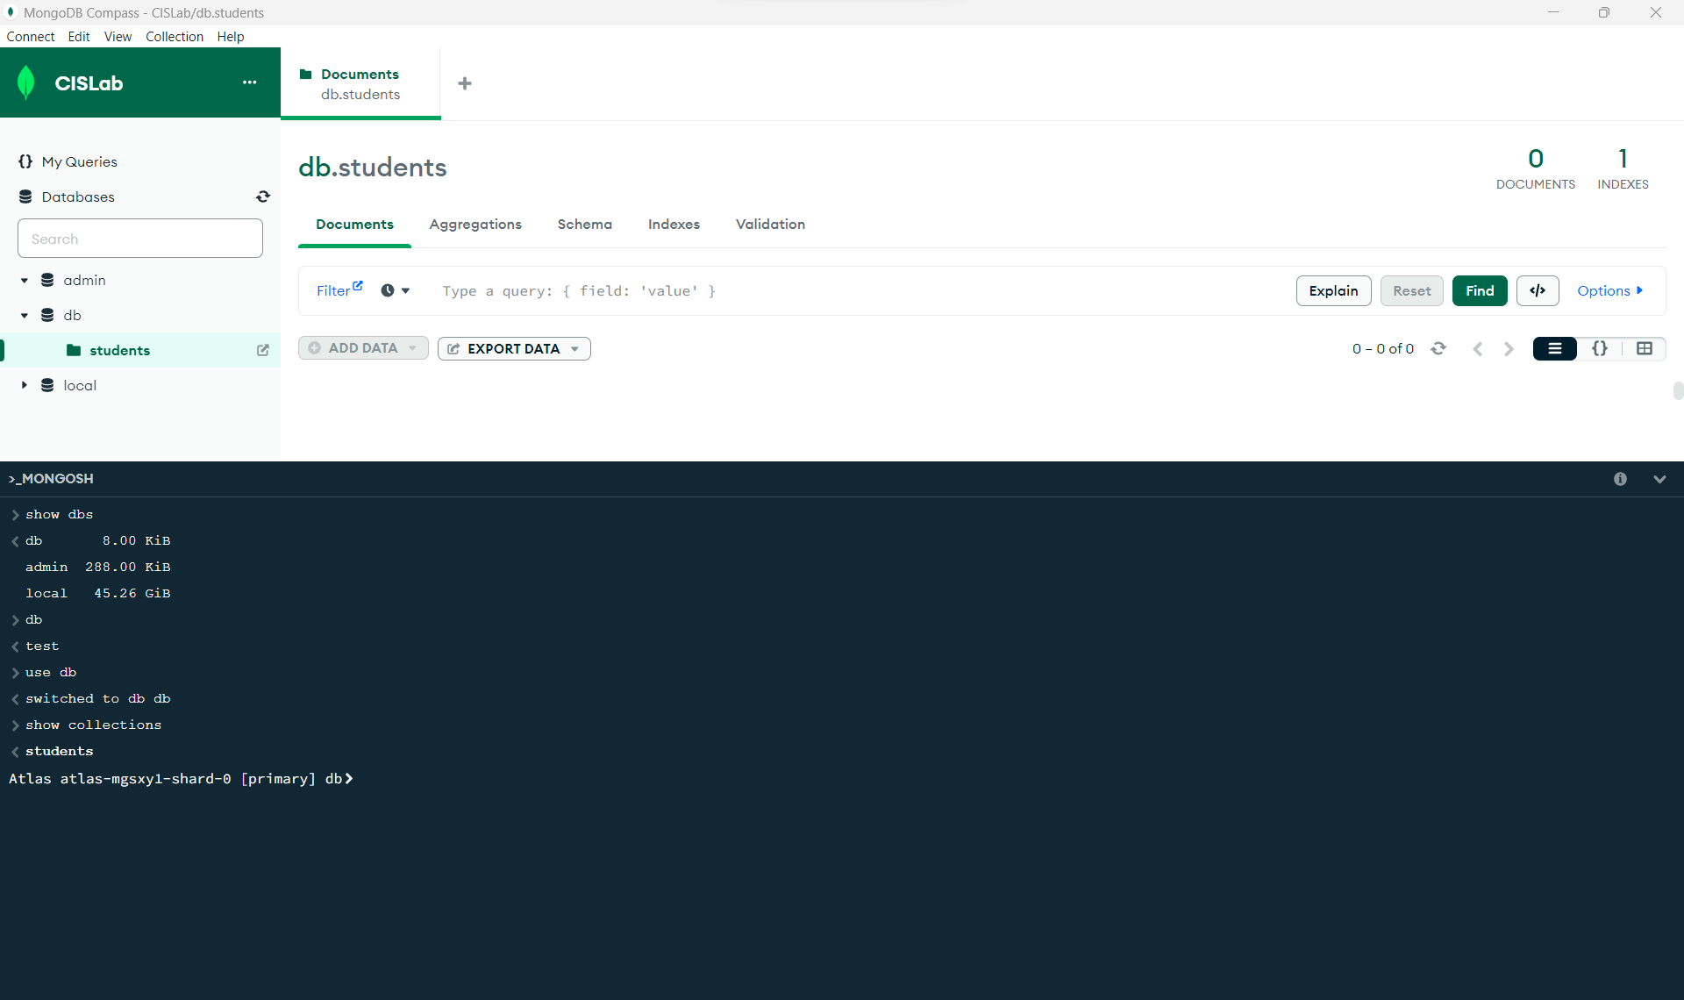

Step 2.2:

show dbs

db 8.00 KiB

admin 288.00 KiB

local 45.26 GiB

db

test

use db

switched to db db

show collections

**students**

db.students.insertOne({"gnumber":"G02520113"});

**MongoServerSelectionError:** 2242304:error:10000438:SSL routines:OPENSSL_internal:TLSV1_ALERT_INTERNAL_ERROR:..\..\third_party\boringssl\src\ssl\tls_record.cc:592:SSL alert number 80

db.students.insertOne({"gnumber":"G02520113"});

{

acknowledged: true,

insertedId: ObjectId("65035a6664ecb97b3bf288d1")

}

db.students.insertOne(

{

"gnum":"G02520113",

"firstname":"Mallikarjuna Rao",

"middlename":null,

"lastname":"Mannem",

"hobbies":["Badminton", "8ball", "Outdoorsing",0,null],

"age":27,

"gpa":0.0,

"gradstudent":true,

"currentlyenrolled":true,

"bikes":[

{ "make":"RE", "model":"Classic 350 (Grey)" },

{ "make":"Yamaha", "model":["R15 (Black)"] }

],

"x":[{"key1":"val1"},{"key2":"val2","key3":"val3"}]

})

{

acknowledged: true,

insertedId: ObjectId("65035d8464ecb97b3bf288d2")

}

db.students.find()

{

_id: ObjectId("65035a6664ecb97b3bf288d1"),

gnumber: 'G02520113'

}

{

_id: ObjectId("65035d8464ecb97b3bf288d2"),

gnum: 'G02520113',

firstname: 'Mallikarjuna Rao',

middlename: null,

lastname: 'Mannem',

hobbies: [

'Badminton',

'8ball',

'Outdoorsing',

0,

null

],

age: 27,

gpa: 0,

gradstudent: true,

currentlyenrolled: true,

bikes: [

{

make: 'RE',

model: 'Classic 350 (Grey)'

},

{

make: 'Yamaha',

model: [

'R15 (Black)'

]

}

],

x: [

{

key1: 'val1'

},

{

key2: 'val2',

key3: 'val3'

}

]

}

db.students.find({ "_id" : ObjectId("65035a6664ecb97b3bf288d1") })

{

_id: ObjectId("65035a6664ecb97b3bf288d1"),

gnumber: 'G02520113'

}

db.students.find({ "_id" : ObjectId("65035d8464ecb97b3bf288d2") }, {firstname:1,age:1})

{

_id: ObjectId("65035d8464ecb97b3bf288d2"),

firstname: 'Mallikarjuna Rao',

age: 27

}

db.students.find(

{

"gradstudent":true,

age: {$gt: 26},

lastname : {$in: ["Smith", "Brown", "Jones"]}

}

)

db.students.find(

{

"gradstudent":true,

age: {$gt: 26},

lastname : {$in: ["Smith", "Mannem", "Jones"]}

}

)

{

_id: ObjectId("65035d8464ecb97b3bf288d2"),

gnum: 'G02520113',

firstname: 'Mallikarjuna Rao',

middlename: null,

lastname: 'Mannem',

hobbies: [

'Badminton',

'8ball',

'Outdoorsing',

0,

null

],

age: 27,

gpa: 0,

gradstudent: true,

currentlyenrolled: true,

bikes: [

{

make: 'RE',

model: 'Classic 350 (Grey)'

},

{

make: 'Yamaha',

model: [

'R15 (Black)'

]

}

],

x: [

{

key1: 'val1'

},

{

key2: 'val2',

key3: 'val3'

}

]

}

db.students.find(

{

"gradstudent":true,

age: {$lt: 26},

lastname : {$in: ["Smith", "Mannem", "Jones"]}

}

)

db.students.find(

{

$or: [

{"gradstudent":true},

{age: {$gt: 26}},

{lastname : {$in: ["Smith", "Brown", "Jones"]}}

]

}

)

{

_id: ObjectId("65035d8464ecb97b3bf288d2"),

gnum: 'G02520113',

firstname: 'Mallikarjuna Rao',

middlename: null,

lastname: 'Mannem',

hobbies: [

'Badminton',

'8ball',

'Outdoorsing',

0,

null

],

age: 27,

gpa: 0,

gradstudent: true,

currentlyenrolled: true,

bikes: [

{

make: 'RE',

model: 'Classic 350 (Grey)'

},

{

make: 'Yamaha',

model: [

'R15 (Black)'

]

}

],

x: [

{

key1: 'val1'

},

{

key2: 'val2',

key3: 'val3'

}

]

}

db.students.find( { hobbies: [

'Badminton',

'8ball',

'Outdoorsing',

0,

null

]

} )

{

_id: ObjectId("65035d8464ecb97b3bf288d2"),

gnum: 'G02520113',

firstname: 'Mallikarjuna Rao',

middlename: null,

lastname: 'Mannem',

hobbies: [

'Badminton',

'8ball',

'Outdoorsing',

0,

null

],

age: 27,

gpa: 0,

gradstudent: true,

currentlyenrolled: true,

bikes: [

{

make: 'RE',

model: 'Classic 350 (Grey)'

},

{

make: 'Yamaha',

model: [

'R15 (Black)'

]

}

],

x: [

{

key1: 'val1'

},

{

key2: 'val2',

key3: 'val3'

}

]

}

db.students.find( { hobbies: "Badminton" } )

{

_id: ObjectId("65035d8464ecb97b3bf288d2"),

gnum: 'G02520113',

firstname: 'Mallikarjuna Rao',

middlename: null,

lastname: 'Mannem',

hobbies: [

'Badminton',

'8ball',

'Outdoorsing',

0,

null

],

age: 27,

gpa: 0,

gradstudent: true,

currentlyenrolled: true,

bikes: [

{

make: 'RE',

model: 'Classic 350 (Grey)'

},

{

make: 'Yamaha',

model: [

'R15 (Black)'

]

}

],

x: [

{

key1: 'val1'

},

{

key2: 'val2',

key3: 'val3'

}

]

}

db.students.find( { hobbies.2: "8ball" } )

**Error:** clone(t={}){const r=t.loc||{};return e({loc:new Position("line"in r?r.line:this.loc.line,"column"in r?r.column:...<omitted>...)} could not be cloned.

db.students.find( { "hobbies.2": "8ball" } )

db.students.find( { "hobbies.1": "8ball" } )

{

_id: ObjectId("65035d8464ecb97b3bf288d2"),

gnum: 'G02520113',

firstname: 'Mallikarjuna Rao',

middlename: null,

lastname: 'Mannem',

hobbies: [

'Badminton',

'8ball',

'Outdoorsing',

0,

null

],

age: 27,

gpa: 0,

gradstudent: true,

currentlyenrolled: true,

bikes: [

{

make: 'RE',

model: 'Classic 350 (Grey)'

},

{

make: 'Yamaha',

model: [

'R15 (Black)'

]

}

],

x: [

{

key1: 'val1'

},

{

key2: 'val2',

key3: 'val3'

}

]

}

db.students.insertOne(

{

"gnum":"G0001234",

"firstname":"Jonathan",

"middlename":null,

"lastname":"Smith",

"hobbies":["SCUBA", "Falconry", "Gardening", "Outdoorsing",0,null],

"age":25,

"gpa":3.9,

"gradstudent":true,

"currentlyenrolled":false,

"cars":[

{ "make":"Ford", "model":["F150 (Red)", "F150 Crew Cab (Black)"] },

{ "make":"Chevy", "model":["Equinox (Silver)"] }

],

"x":[{"key1":"val1"},{"key2":"val2","key3":"val3"}]

})

{

acknowledged: true,

insertedId: ObjectId("650361b164ecb97b3bf288d3")

}

db.students.updateMany({

_id :ObjectId("650361b164ecb97b3bf288d3")},

{$set:{"skills":

{db:"MongoDB", version:5, nosql:"document"}

}

})

{

acknowledged: true,

insertedId: null,

matchedCount: 1,

modifiedCount: 1,

upsertedCount: 0

}

db.students.find({ "_id" : ObjectId("650361b164ecb97b3bf288d3") })

{

_id: ObjectId("650361b164ecb97b3bf288d3"),

gnum: 'G0001234',

firstname: 'Jonathan',

middlename: 'B',

lastname: 'Smith',

hobbies: [

'SCUBA',

'Falconry',

'Gardening',

'Outdoorsing',

0,

null

],

age: 25,

gpa: 3.9,

gradstudent: true,

currentlyenrolled: false,

cars: [

{

make: 'Ford',

model: [

'F150 (Red)',

'F150 Crew Cab (Black)'

]

},

{

make: 'Chevy',

model: [

'Equinox (Silver)'

]

}

],

x: [

{

key1: 'val1'

},

{

key2: 'val2',

key3: 'val3'

}

],

skills: {

db: 'MongoDB',

version: 5,

nosql: 'document'

},

status: 'Cum Laude'

}

db.students.insertOne({hello:"world"})

{

acknowledged: true,

insertedId: ObjectId("65038fb364ecb97b3bf288d4")

}

db

db

db.students.find()

{

_id: ObjectId("65035a6664ecb97b3bf288d1"),

gnumber: 'G02520113'

}

{

_id: ObjectId("65035d8464ecb97b3bf288d2"),

gnum: 'G02520113',

firstname: 'Mallikarjuna Rao',

middlename: null,

lastname: 'Mannem',

hobbies: [

'Badminton',

'8ball',

'Outdoorsing',

0,

null

],

age: 27,

gpa: 0,

gradstudent: true,

currentlyenrolled: true,

bikes: [

{

make: 'RE',

model: 'Classic 350 (Grey)'

},

{

make: 'Yamaha',

model: [

'R15 (Black)'

]

}

],

x: [

{

key1: 'val1'

},

{

key2: 'val2',

key3: 'val3'

}

]

}

{

_id: ObjectId("650361b164ecb97b3bf288d3"),

gnum: 'G0001234',

firstname: 'Jonathan',

middlename: 'B',

lastname: 'Smith',

hobbies: [

'SCUBA',

'Falconry',

'Gardening',

'Outdoorsing',

0,

null

],

age: 25,

gpa: 3.9,

gradstudent: true,

currentlyenrolled: false,

cars: [

{

make: 'Ford',

model: [

'F150 (Red)',

'F150 Crew Cab (Black)'

]

},

{

make: 'Chevy',

model: [

'Equinox (Silver)'

]

}

],

x: [

{

key1: 'val1'

},

{

key2: 'val2',

key3: 'val3'

}

],

skills: {

db: 'MongoDB',

version: 5,

nosql: 'document'

},

status: 'Cum Laude'

}

{

_id: ObjectId("65038fb364ecb97b3bf288d4"),

hello: 'world'

}

db.students.deleteOne({hello:"world"})

{

acknowledged: true,

deletedCount: 1

}

db.students.find()

{

_id: ObjectId("65035a6664ecb97b3bf288d1"),

gnumber: 'G02520113'

}

{

_id: ObjectId("65035d8464ecb97b3bf288d2"),

gnum: 'G02520113',

firstname: 'Mallikarjuna Rao',

middlename: null,

lastname: 'Mannem',

hobbies: [

'Badminton',

'8ball',

'Outdoorsing',

0,

null

],

age: 27,

gpa: 0,

gradstudent: true,

currentlyenrolled: true,

bikes: [

{

make: 'RE',

model: 'Classic 350 (Grey)'

},

{

make: 'Yamaha',

model: [

'R15 (Black)'

]

}

],

x: [

{

key1: 'val1'

},

{

key2: 'val2',

key3: 'val3'

}

]

}

{

_id: ObjectId("650361b164ecb97b3bf288d3"),

gnum: 'G0001234',

firstname: 'Jonathan',

middlename: 'B',

lastname: 'Smith',

hobbies: [

'SCUBA',

'Falconry',

'Gardening',

'Outdoorsing',

0,

null

],

age: 25,

gpa: 3.9,

gradstudent: true,

currentlyenrolled: false,

cars: [

{

make: 'Ford',

model: [

'F150 (Red)',

'F150 Crew Cab (Black)'

]

},

{

make: 'Chevy',

model: [

'Equinox (Silver)'

]

}

],

x: [

{

key1: 'val1'

},

{

key2: 'val2',

key3: 'val3'

}

],

skills: {

db: 'MongoDB',

version: 5,

nosql: 'document'

},

status: 'Cum Laude'

}

db.students.insertOne({hello:"world"})

{

acknowledged: true,

insertedId: ObjectId("6503909c64ecb97b3bf288d5")

}

db.students.deleteMany({hello:"world"})

{

acknowledged: true,

deletedCount: 1

}

Atlas atlas-mgsxy1-shard-0 [primary] db

**–> GUI interaction and website browsing are user friendly. Modifications are easy to perform.**

**Step #3:** Use MongoDB CRUD commands to store and manipulate a custom dataset Refer to these MongoDB examples. Keep a copy of all of your commands to turn in. Execute the commands and record the output from each step.

1. Download a simple, small dataset of JSON documents of your choice.

Energy Census and Economic Data US 2010-2014

2. Add at least five SEPARATE documents based on a subset of your dataset – 10% grade. Note to yourself: how is this different than inserting one document that contains five sub-documents? Hint: DO NOT insert one big document that contains five nestled sub-documents! Each document should get its own document ID.

Imported data using a csv file. 52 datasets.

3. Generate a query that retrieves a document based on its unique id – 20% grade.

db.students.find({ "_id" : ObjectId("6503bcc3355d9dc62be482b6") })

{

GDP2010: 57673.75,

GDP2011Q1: 58760,

GDP2011Q2: 59581,

GDP2011Q3: 60648,

GDP2011Q4: 60064,

GDP2011: 59763.25,

GDP2012Q1: 61230,

GDP2012Q2: 61132,

GDP2012Q3: 60865,

GDP2012Q4: 59870,

GDP2012: 60774.25,

GDP2013Q1: 60295,

GDP2013Q2: 60868,

GDP2013Q3: 61092,

GDP2013Q4: 63440,

GDP2013: 61423.75,

GDP2014Q1: 63270,

GDP2014Q2: 65382,

GDP2014Q3: 66893,

GDP2014Q4: 66394,

GDP2014: 65484.75,

CENSUS2010POP: 897934,

POPESTIMATE2010: 899731,

POPESTIMATE2011: 907829,

POPESTIMATE2012: 916881,

POPESTIMATE2013: 925240,

POPESTIMATE2014: 935614,

RBIRTH2011: 12.50304278,

RBIRTH2012: 12.22879252,

RBIRTH2013: 11.95686928,

RBIRTH2014: 11.96654869,

RDEATH2011: 8.714510168,

RDEATH2012: 8.438601202,

RDEATH2013: 8.850667247,

RDEATH2014: 8.896990307,

RNATURALINC2011: 3.788532608,

RNATURALINC2012: 3.790191318,

RNATURALINC2013: 3.106202036,

RNATURALINC2014: 3.069558386,

RINTERNATIONALMIG2011: 2.436433645,

RINTERNATIONALMIG2012: 2.62288254,

RINTERNATIONALMIG2013: 2.608949141,

RINTERNATIONALMIG2014: 2.565488749,

RDOMESTICMIG2011: 2.866848127,

RDOMESTICMIG2012: 3.598380017,

RDOMESTICMIG2013: 3.397170979,

RDOMESTICMIG2014: 5.148173903,

RNETMIG2011: 5.303281772,

RNETMIG2012: 6.221262557,

RNETMIG2013: 6.006120119,

RNETMIG2014: 7.713662652

}

Atlas atlas-mgsxy1-shard-0 [primary] db

4. Generate a query that utilizes an ‘and’ condition – 20% grade.

db.students.find(

{

Region: {$lt: 4},

State: {$in: ["Michigan", "Arizona"]}

}

)

{

GDP2010: 387167,

GDP2011Q1: 395349,

GDP2011Q2: 396078,

GDP2011Q3: 400884,

GDP2011Q4: 413128,

GDP2011: 401359.75,

GDP2012Q1: 412761,

GDP2012Q2: 416887,

GDP2012Q3: 419650,

GDP2012Q4: 420015,

GDP2012: 417328.25,

GDP2013Q1: 428265,

GDP2013Q2: 428285,

GDP2013Q3: 431136,

GDP2013Q4: 436760,

GDP2013: 431111.5,

GDP2014Q1: 438271,

GDP2014Q2: 445584,

GDP2014Q3: 450840,

GDP2014Q4: 454190,

GDP2014: 447221.25,

CENSUS2010POP: 9883640,

POPESTIMATE2010: 9876498,

POPESTIMATE2011: 9875736,

POPESTIMATE2012: 9884781,

POPESTIMATE2013: 9898193,

POPESTIMATE2014: 9909877,

RBIRTH2011: 11.54168182,

RBIRTH2012: 11.44403256,

RBIRTH2013: 11.41092335,

RBIRTH2014: 11.38404701,

RDEATH2011: 9.100641477,

RDEATH2012: 9.015351167,

RDEATH2013: 9.05687891,

RDEATH2014: 9.124160002,

RNATURALINC2011: 2.44104034,

RNATURALINC2012: 2.428681395,

RNATURALINC2013: 2.354044443,

RNATURALINC2014: 2.259887006,

RINTERNATIONALMIG2011: 1.825616282,

RINTERNATIONALMIG2012: 1.87161095,

RINTERNATIONALMIG2013: 2.029017477,

RINTERNATIONALMIG2014: 2.028870051,

RDOMESTICMIG2011: -4.371657403,

RDOMESTICMIG2012: -3.394243177,

RDOMESTICMIG2013: -2.98681078,

RDOMESTICMIG2014: -2.895688474,

RNETMIG2011: -2.546041121,

RNETMIG2012: -1.522632227,

RNETMIG2013: -0.957793302,

RNETMIG2014: -0.866818423

}

Atlas atlas-mgsxy1-shard-0 [primary] db

Selection deleted

5. Generate a query that utilizes an ‘or’ condition – 20% grade.

db.students.find(

{ $or: [

{ Region: {$lt: 1}},

{ State: {$in: ["Michigan"]}}

]}

)

LPGE2013: 1145.7,

LPGE2014: 1273.4,

LPGPrice2010: 22.72,

LPGPrice2011: 23.91,

LPGPrice2012: 22.5,

LPGPrice2013: 24.33,

LPGPrice2014: 27.78,

GDP2010Q1: 373593,

GDP2010Q2: 386054,

GDP2010Q3: 394845,

GDP2010Q4: 394176,

GDP2010: 387167,

GDP2011Q1: 395349,

GDP2011Q2: 396078,

GDP2011Q3: 400884,

GDP2011Q4: 413128,

GDP2011: 401359.75,

GDP2012Q1: 412761,

GDP2012Q2: 416887,

GDP2012Q3: 419650,

GDP2012Q4: 420015,

GDP2012: 417328.25,

GDP2013Q1: 428265,

GDP2013Q2: 428285,

GDP2013Q3: 431136,

GDP2013Q4: 436760,

GDP2013: 431111.5,

GDP2014Q1: 438271,

GDP2014Q2: 445584,

GDP2014Q3: 450840,

GDP2014Q4: 454190,

GDP2014: 447221.25,

CENSUS2010POP: 9883640,

POPESTIMATE2010: 9876498,

POPESTIMATE2011: 9875736,

POPESTIMATE2012: 9884781,

POPESTIMATE2013: 9898193,

POPESTIMATE2014: 9909877,

RBIRTH2011: 11.54168182,

RBIRTH2012: 11.44403256,

RBIRTH2013: 11.41092335,

RBIRTH2014: 11.38404701,

RDEATH2011: 9.100641477,

RDEATH2012: 9.015351167,

RDEATH2013: 9.05687891,

RDEATH2014: 9.124160002,

RNATURALINC2011: 2.44104034,

RNATURALINC2012: 2.428681395,

RNATURALINC2013: 2.354044443,

RNATURALINC2014: 2.259887006,

RINTERNATIONALMIG2011: 1.825616282,

RINTERNATIONALMIG2012: 1.87161095,

RINTERNATIONALMIG2013: 2.029017477,

RINTERNATIONALMIG2014: 2.028870051,

RDOMESTICMIG2011: -4.371657403,

RDOMESTICMIG2012: -3.394243177,

RDOMESTICMIG2013: -2.98681078,

RDOMESTICMIG2014: -2.895688474,

RNETMIG2011: -2.546041121,

RNETMIG2012: -1.522632227,

RNETMIG2013: -0.957793302,

RNETMIG2014: -0.866818423

}

Atlas atlas-mgsxy1-shard-0 [primary] db

Selection deleted

6. Update one document by adding a new field based on an updateOne or updateMany statement – 10% grade.

db.students.updateMany(

{State:"California"},

{$set:{"StateCode":"CAL"}}

)

{

acknowledged: true,

insertedId: null,

matchedCount: 1,

modifiedCount: 1,

upsertedCount: 0

}

Atlas atlas-mgsxy1-shard-0 [primary] db

7. Delete one or more documents – 10% grade.

db.students.deleteMany(

{State:"California"}

)

{

acknowledged: true,

deletedCount: 1

}

Atlas atlas-mgsxy1-shard-0 [primary] db

Selection deleted

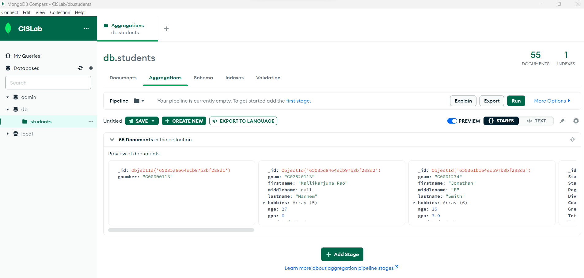

Done for the day!